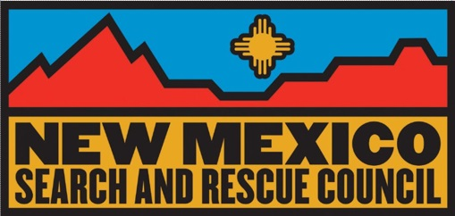

New Mexico Search and Rescue Council
Board Meeting Minutes
August 13, 2018 (19:00)

In Attendance: David Price, Jon Hitchcock, Michaela Buenemann, Terry Ann Miller, Ruth Neal, Scott Voorhees, Erik Nelson, Ron Nelson, Eric Roybal.

Absent: Sean McGann, Aimee Adamek

Meeting called to order by David Price at 19:03

Agenda: Approved without changes.

Minutes of June 18, 2018, meeting approved subject to corrections.

Old Business:

Discussion regarding a SAR medical director, it is still being worked on.

Changes to bylaws will be discussed next meeting. Everyone is asked to review draft for conflicts.

New Business:

Mapping: Erik will call state to see if they can do large format printing and will do research concerning large format printers for acquisition by NMSARC.

Escape 2019 David will look into camping spaces around Ruidoso. Terry Ann has been looking for a place to work with dogs near the event location.

Treasurer’s Report: Jon Hitchcock Jon reported that there was not much change in the year to date activity by class. Second half of Escape 2019 deposit is due in September or October. David asked about a $3,500.00 donation that came in in June. Jon confirmed that $3,750.00 was received on June 15, 2018, however it was not reflected in the statements he provided.

Membership: Terry Miller The dues statements will go out earlier this year. Terry is hopeful that the on-line process will get the dues paid on time. She wants to contact non-member teams and asked if board members knew any members of teams that are not NMSARC members

Training Updates: Sean McGann Sean was not present. David explained why there had been no payment for the tracking class at Escape. The instructor wants payment in hand at the conclusion of the class. There may be a way to get the checks in advance and meet the requirements of the state accounting system. The state needs a W-9 from the instructors to put them into the accounting system. One issue is that not enough students show up for the classes and instructors need a guarantee.

Communications: Ron and Erik Nelson There is an agreement between the Forest Service, Department of the Interior and the State of New Mexico on sharing radio frequencies. Eric Roybal said that Terry Morton had been working on an agreement with the agencies concerning SAR using the frequencies.

There was discussion of NMSARC representative at review board. Some board members felt that Bob Baker is not representing NMSARC at the review board. His term ends in a few months and there was discussion about how we could put a new person in his place. David will look into it.

Next meeting is set for October 8, 2018 at 7:00 p.m.

Meeting adjourned at 8:01

